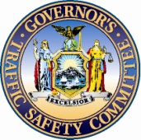 | 2011 Operation Safe Stop Reporting Form for March 30, 2011 | 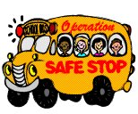

Law Enforcement Violation Report

Law Enforcement Officials should use this form to report OSS violation information to the Governor’s Traffic Safety Committee, by Fax (518) 473-6946 or email: grants@safeny.com.

This information will be summarized on a statewide basis and forwarded to the Governor’s Office.
Agency Name:
Agency County:
Name of officer/person completing the form:
Phone Number:
Email Address:
Number of 1174 citations issued:
Number of other Uniform Traffic Tickets issued:
Number of Arrests made:
Number of Participating Officers:
Did your agency participate in an Operation Safe Stop press event? Yes No
Did your agency issue an Operation Safe Stop press release? Yes No
Did your agency distribute any Public Information and Education materials? Yes No
Did your agency participate in a media ride along? Yes No
If yes, please describe what media outlet you partnered with during OSS Day?
Please comment on any notable accomplishments which occurred by participating in OSS Day?

GTSC would like to thank you for your participation in this educational law enforcement program. It is through your support that the public will become more aware of the dangers of passing a stopped school bus with flashing red lights and violating Section 1174 of the New York State Vehicle and Traffic Law.

